2026 – 2027 Mary Gates Atkinson Scholarship Recipients

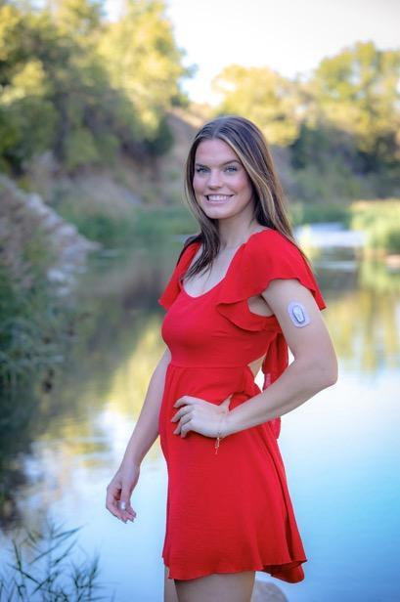
Alyssa Wolff Alyssa will be going to Washburn Tech as a Junior next year studying nursing. The address she has for mail and encouragement is 1940 Heatherwood Dr., Unit 208, Lawrence, Kansas 66047. Her phone number is: 785-407-7207. Her email is alyssa_wolff@icloud.com. Her birthday is 12-19. She works with the Visiting Nurses Association in Lawrence. Her pastor shares: “She was drawn to nursing at five years old sitting at her grandmother’s hospital bed. A nurse noticed the curiosity in her young eyes and invited her to assist in her grandmother’s care.” At nine she was diagnosed with Type 1 diabetes. Since 7th grade she has faithfully served in their “King’s Kids” program.


Kanika Marcoux Kanika will be going to Pittsburg State University seeking her BS in Psychology with an emphasis in legal issues. You can write to her at: 1024 S. Gretchen Ave., Chanute Ks. 66720. Her phone number: 620-212-1528. Her email is: kanikamarcoux@gmail.com. Her birthday is October 3rd. She works as a paralegal at a law office. She has started a girls’ Bible study because she saw the need for more women’s discipleship and community. Her pastor shares: “Kanika is trustworthy, dependable, and driven. What sets her apart is her versatility and willingness to learn.”


Tyra Henson is entering her Senior year at Pittsburg State University to obtain a nursing degree. You can mail her cards and encouragement to 1118 W. 1st St., Pittsburg, KS. 66762. Her email address: tyrabogle@gmail.com. Her phone #: 620-432-3934. Her birthday is October 07. Her husband, Parker Henson, is also a student and will be graduating from Pitt State 2026 winter semester. They are expecting their first child September 10. Currently she is a CNA at a senior assisted living. She enjoys tennis, painting, basketball and any kind of new craft. “A special talent I have is helping my nursing friends pass exams. We all study together and I have found out that I explain concepts well and make it easier for them to understand.”


Amy Marcoux Amy is entering her senior year at Pittsburg State University’s Master’s Program-Clinical Psychology. You can mail her cards and encouragement at 1024 S. Gretchen Ave., Chanute, Ks. 66720. Her email is amarcoux@gus.pittstate.edu. Her phone: 815-685-5728. Her birthday is June 5th.
She is a pastor’s wife and she is in a full-time graduate program. Their oldest daughter is following in her footsteps (Kanika), second daughter is a freshman in high school, third is a fourth-grader. Amy is also a writer, contributing to Midwest Quarterly connecting the mental health impact of dyslexia to the clinical work she does at the Center for READing at PSU.


Paige Campbell Paige is in her senior year at Northwest Missouri State University in Graphic Design. Cards and letters can be sent to: 900 N. 6th St., Hiawatha, Ks. 66434. Her phone number: 785-741-4609. Her email: paigywaggie@gmail.com. Her birthday is Dec. 15th. She is active in two churches; one at school called The Bridge, and the other at home, FBC. She is a twin, and loves “guy” things, for example, going mudding in her four-wheeler, wrestling, building bonfires, and learning to change her car’s oil and tires. She also refined and digitized a drawing done by one of her church’s elementary students and it is now the logo for their after school “Breakout” program.

